**Lab-3 Assignment**

**1)Program to find addition and subtraction of two complex numbers**

**Algorithm:** At first, we are declaring a structure named complex with real and imaginary numbers then we are creating two variables from this structure to get the complex number. At main function user will enter the numbers of complex number and it is directed to sum() and Subtract() functions to get the result of the complex numbers.

**Logic:**

#include <stdio.h>

typedef struct complex

{

int r,i;

}CMP;

void sum(CMP a,CMP b)

{

int c,d;

c=a.r+b.r;

d=a.i+b.i;

printf("\nAddition of given two complex numbers is : %d+(%d)i ",c,d);

}

void subtract(CMP a,CMP b)

{

int e,f;

e= a.r-b.r;

f= a.i-b.i;

printf("\nSubtraction of given two complex numbers is : %d+(%d)i ",e,f);

}

void main()

{

CMP n1,n2;

printf("Enter real and imaginary part of 1st complex number:");

scanf("%d %d",&n1.r,&n1.i);

printf("Enter real and imaginary part of 1st complex number:");

scanf("%d %d",&n2.r,&n2.i);

printf("Entered complex numbers are %d+(%d)i and %d+(%d)i",n1.r,n1.i,n2.r,n2.i);

sum(n1,n2);

subtract(n1,n2);

printf("\nSubmitted by Gelle Hruthesh Reddy Admn.No 20BCB7031");

}

**Output:**

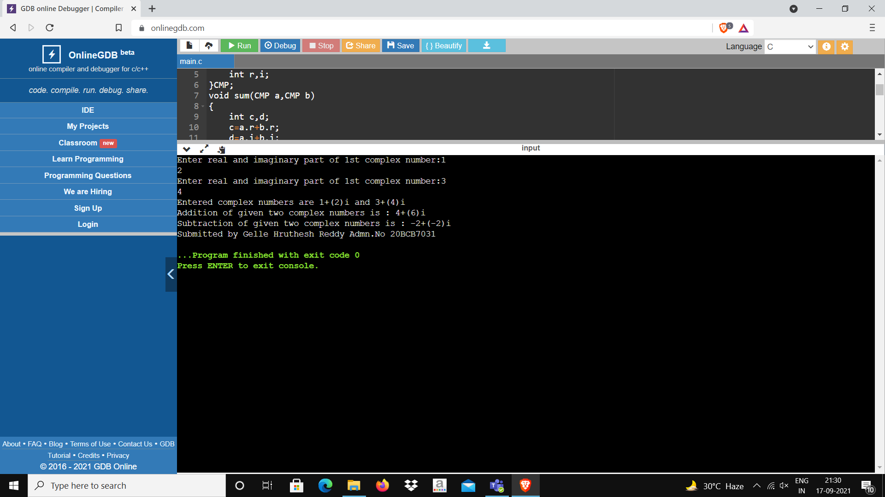

**2)C++ program to illustrate new and delete keywords for dynamic memory allocation**

**Algorithm:** In this program the user must give the number of subjects of the student, and we have the allocated the memory dynamically for the mark array using new. After entering and printing the data using pointer, we are going to deallocate the array memory using delete [] mark.

**Logic:**

#include <iostream>

using namespace std;

int main(){

int n;

cout<<"Enter total number of subjects: ";

cin>>n;

int* mark;

mark=new int[n];

cout<<"Enter the marks of Students: "<<endl;

for(int i=0;i<n;++i){

cout<<"Subject"<<i+1<<": ";

cin>>*(mark+i);

}

cout<<"\nMarks of Student: "<<endl;

for(int i=0;i<n;++i){

cout<<"Subject"<<i+1<<" :"<<*(mark+i)<<endl;

}

delete[] mark;

cout<<"\nSubmitted by Gelle Hruthesh Reddy Admn.No 20BCB7031"<<endl;

return 0;

}

**Output:**

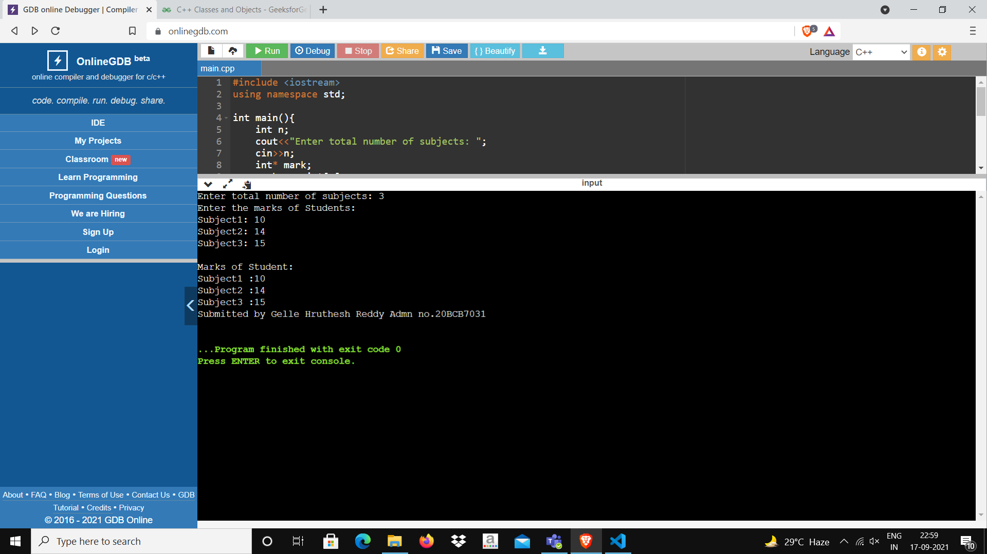

**3)C++ program for illustrating class declarations, definitions, and accessing class members**

**Algorithm:** First we are declaring the variables and then we have created two functions inside the class, and one is not defined other one is defined. We are bringing the function using scope resolution operator. After that we are going to call that function to do the operation by accessing class members.

**Logic:**

#include <iostream>

using namespace std;

class Student

{

public:

string name;

int Admn;

void names();

void no()

{

cout<<"Student Admn.no is: "<<Admn;

}

};

void Student::names()

{

cout<<"Student name is: "<<name;

}

int main(){

Student obj;

obj.name="Gelle Hruthesh Reddy";

obj.Admn=7031;

obj.names();

cout<<endl;

obj.no();

cout<<"\nSubmitted by Gelle Hruthesh Reddy Admn.No 20BCB7031"<<endl;

return 0;

}

**Output:**

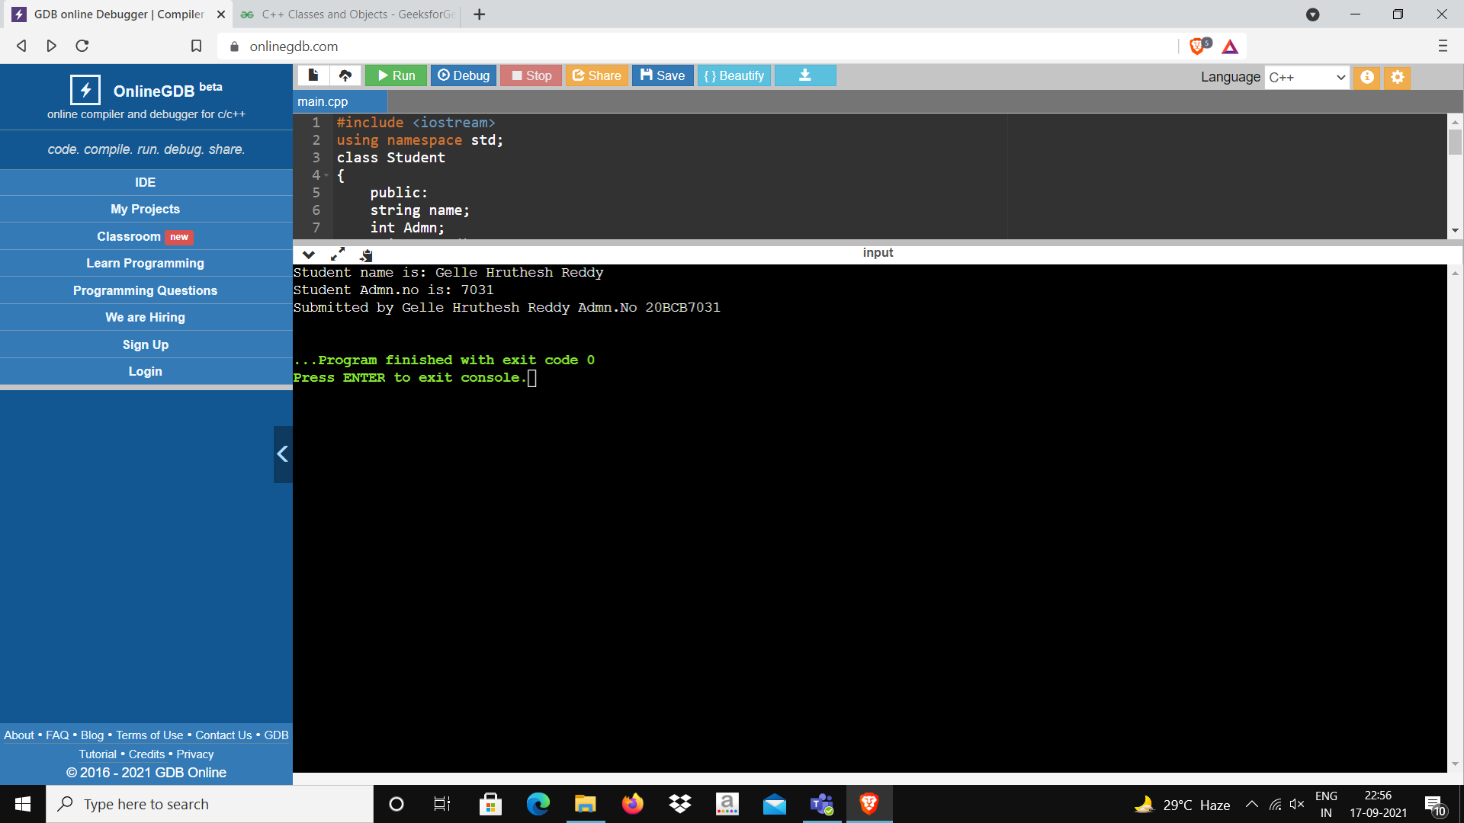

**4)C++ program to implement array of objects**

**Algorithm:** We are declaring the variables in class, and we have created an array of objects for the marks, where each object has its name, roll no, marks of the student and in the main function we are calling out the functions and getting the results.

**Logic:**

#include<iostream>

using namespace std;

class student

{

public:

int rollno;

string name;

int marks[5];

void mark()

{

int n,m;

cout<<"Enter total number of students: ";

cin>>n;

for(int i=0;i<n;i++){

cout<<"Enter Roll Number: "<<endl;

cin>>rollno;

cout<<"Enter Name of the student: "<<endl;

cin>>name;

cout<<"Enter No of Subjects"<<endl;

cin>>m;

cout<<"Enter the marks of student: "<<endl;

for(int i=0;i<m;i++)

{

cout<<"Subject"<<i+1<<": ";

cin>>marks[i];

}

}

}

};

int main()

{

student s;

s.mark();

cout<<"Submitted by Gelle Hruthesh Reddy Admn No 20BCB7031"<<endl;

return 0;

}

**Output:**

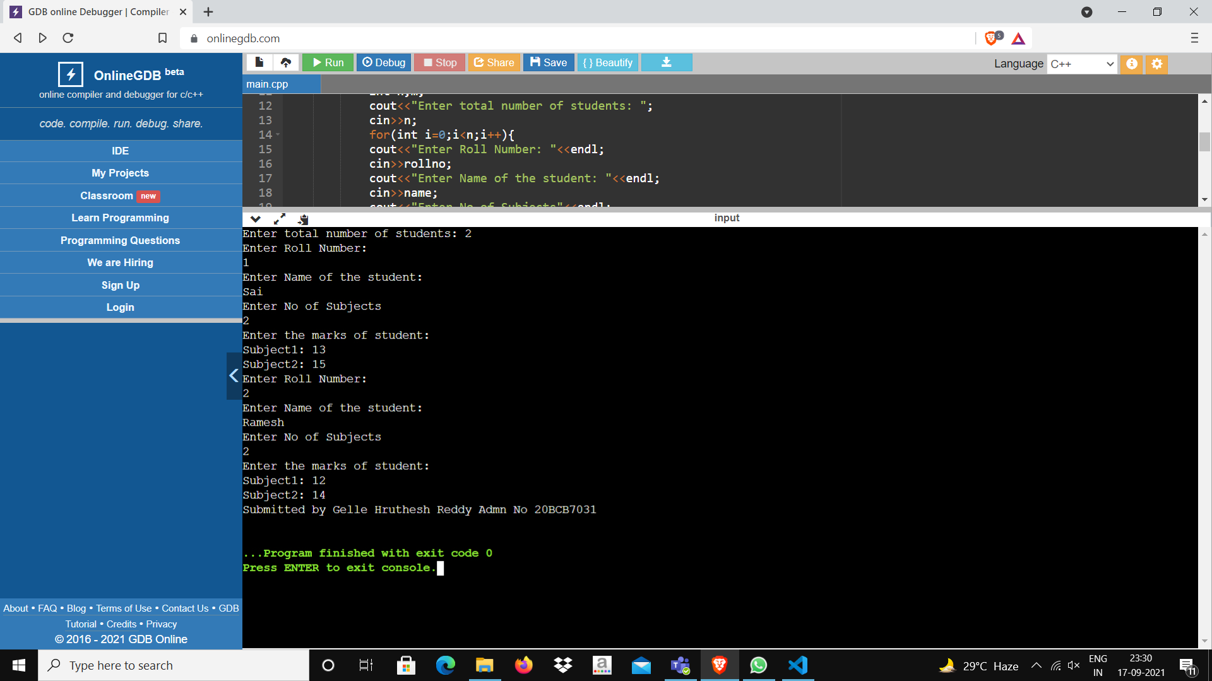**Time of Submission: 18/9/2021,22:00**